Subarray with k different integers
Problem Statement: You are given an integer array nums and an integer k. Return the number of good subarrays of nums.
A good subarray is defined as a contiguous subarray of nums that contains exactly k distinct integers. A subarray is a contiguous part of the array.
Input: nums = [1, 2, 1, 2, 3], k = 2
Output: 7
Explanation: The 7 subarrays with exactly 2 different integers are:
[1,2], [2,1], [1,2], [2,3], [1,2,1], [2,1,2], [1,2,1,2]

Input: nums = [1, 2, 1, 3, 4], k = 3
Output: 3
Explanation: The 3 subarrays with exactly 3 different integers are:
[1,2,1,3], [2,1,3], [1,3,4]
Algorithm
To solve this problem optimally, we utilize the concept of sliding windows to avoid brute force enumeration of all subarrays. The core idea is that calculating the number of subarrays with exactly K distinct integers can be derived by computing: countExactlyK = countAtMostK(K) - countAtMostK(K - 1)
This works because countAtMostK(K) gives the number of subarrays with at most K distinct integers, and countAtMostK(K - 1) gives the number of subarrays with at most (K-1) distinct integers. Their difference gives the number of subarrays with exactly K distinct integers.
The reason this is efficient is because countAtMostK can be computed using the sliding window approach in linear time. We maintain a dynamic window [left, right] such that the number of distinct elements inside it is at most K. As we move the right pointer and extend the window, we shrink the left pointer whenever the constraint is violated, and count all valid subarrays ending at the current right.
This method efficiently avoids checking all subarrays explicitly and leverages properties of inclusion-exclusion over ranges with at most K and K-1 elements.
- Define a helper function that calculates the number of subarrays with at most K distinct elements using a sliding window.
- Initialize two pointers to represent the sliding window boundaries.
- Maintain a frequency map to track the count of each number in the window.
- Expand the window to the right by iterating over the array.
- If the current element is new to the window (i.e., not in the frequency map or has zero count), decrement the K counter.
- While K becomes negative (i.e., more than K distinct elements), shrink the window from the left until the constraint is restored.
- At each step, the number of valid subarrays ending at the current right index is (right - left + 1). Accumulate this count.
- Once you have the count for at most K and at most K-1, subtract to get the final result.
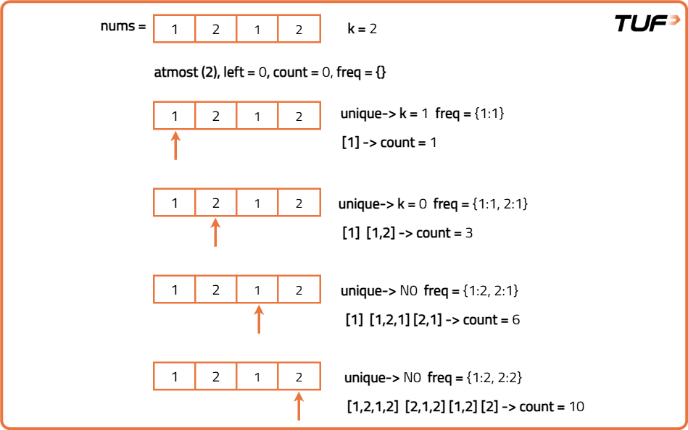
public class Solution {
// Helper function to count subarrays with at most K distinct integers
public int atMostK(int[] nums, int K) {
Map<Integer, Integer> freq = new HashMap<>();
int left = 0, count = 0;
for (int right = 0; right < nums.length; right++) {
freq.put(nums[right], freq.getOrDefault(nums[right], 0) + 1);
if (freq.get(nums[right]) == 1) {
K--;
}
// Shrink the window if K becomes negative
while (K < 0) {
freq.put(nums[left], freq.get(nums[left]) - 1);
if (freq.get(nums[left]) == 0) {
K++;
}
left++;
}
count += (right - left + 1);
}
return count;
}

// Main function to return number of subarrays with exactly K distinct integers
public int subarraysWithKDistinct(int[] nums, int k) {
return atMostK(nums, k) - atMostK(nums, k - 1);
}
}

